28th of April 2025
Data Entered

db.books.insertMany(
[
{
"title": "The Hobbit",
"author": "J.R.R. Tolkien",
"published_year": 1937,
"genres": ["Fantasy", "Adventure"],
"pages": 310,
"available": true,
"rating": 4.8
},

{
"title": "1984",
"author": "George Orwell",
"published_year": 1949,
"genres": ["Dystopian", "Political Fiction"],
"pages": 328,
"available": true,
"rating": 4.7
},
{
"title": "To Kill a Mockingbird",
"author": "Harper Lee",
"published_year": 1960,
"genres": ["Southern Gothic", "Drama"],
"pages": 281,
"available": false,
"rating": 4.6
},
{
"title": "The Great Gatsby",
"author": "F. Scott Fitzgerald",
"published_year": 1925,
"genres": ["Tragedy"],
"pages": 180,
"available": true,
"rating": 4.4
},
{
"title": "Brave New World",
"author": "Aldous Huxley",
"published_year": 1932,
"genres": ["Science Fiction", "Dystopian"],
"pages": 311,
"available": true,
"rating": 4.2
}

]
);

1. Find all books
db.books.find();
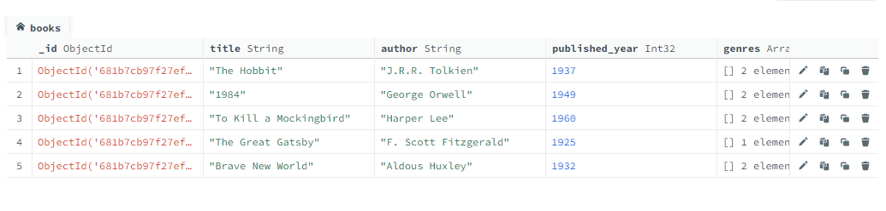

2.Find all books published after 1950
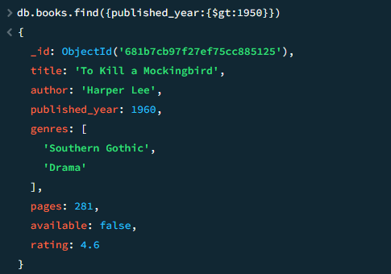
db.books.find({published_year:{$gt:1950}})

3. Find all the available books
db.books.find({available:true})
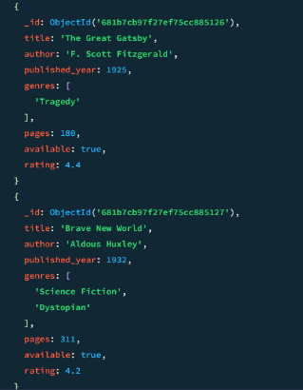
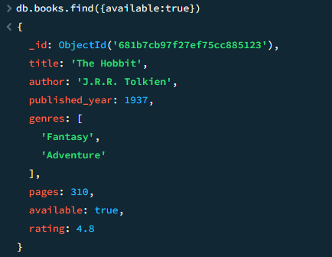
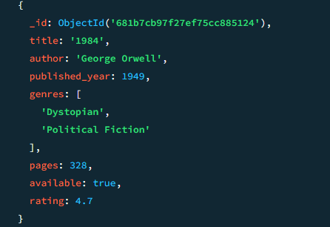

4.Find all books that belong to the "Dystopian" genre
db.books.find({genres:"Dystopian"})
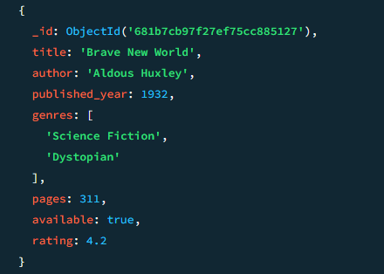
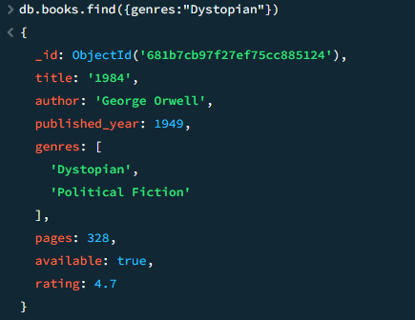

5.Find the books which published after 1960 and had rating more than 4.0.
db.books.find({published_year:{$gt:1950},rating:{$gt:4.0}})
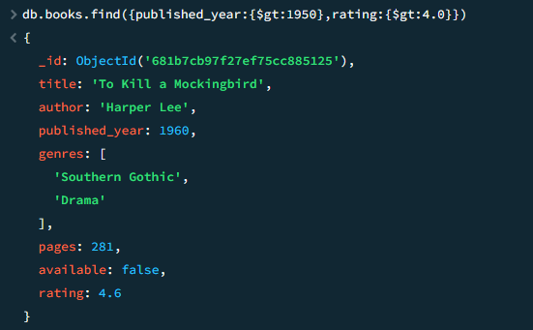

6.Project only title and author fields:
db.books.find({title:1,author:1,_id:-1})
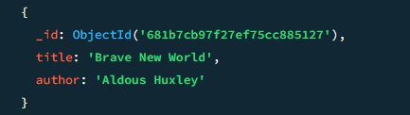
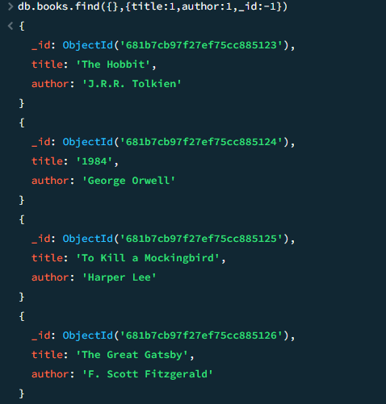

7.Update the book "1984" to set available: false:
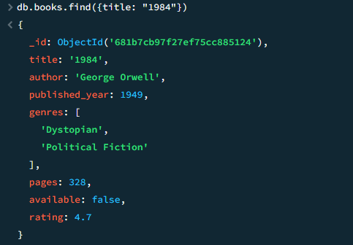
db.books.updateOne.({title: “1984”},{$set:{available: false}})
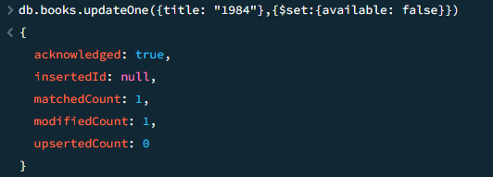

8.Increase the rating of "Brave New World" by +0.1:
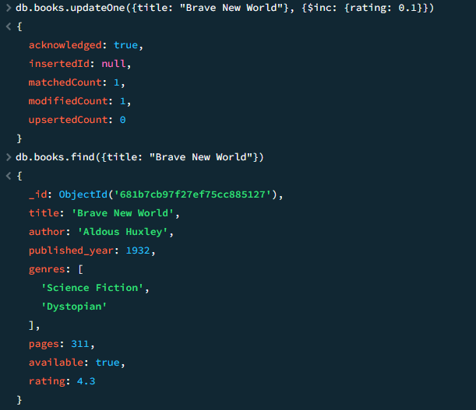
db.books.updateOne({title:” Brave New World”}, {$inc: {rating: 0.1}})

9.Add a new genre "Classic" to "The Great Gatsby":
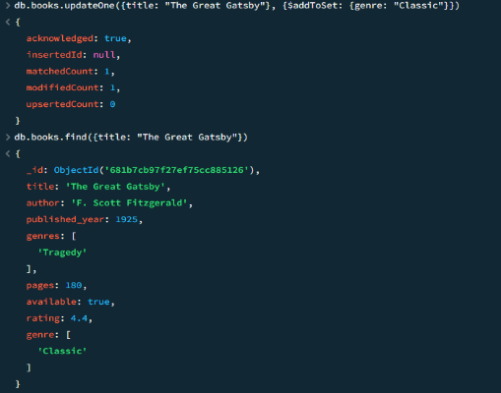
Db.books.updateOne({title: “The Great Gatsby”}, {$addToSet: {genre: “Classic”}})
10.Sort books by published_year ascending:
db.books.find().sort({published_year:1})
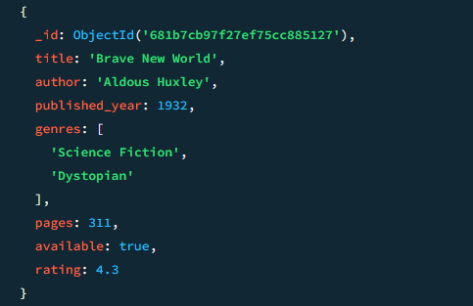
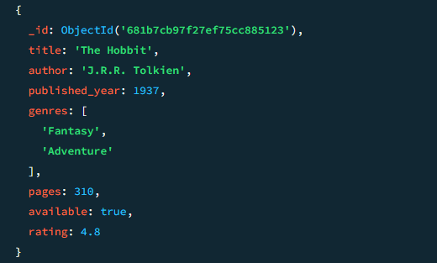
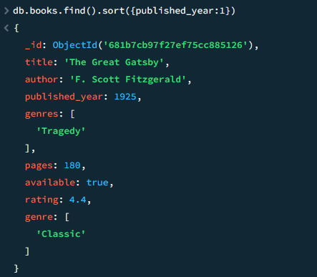
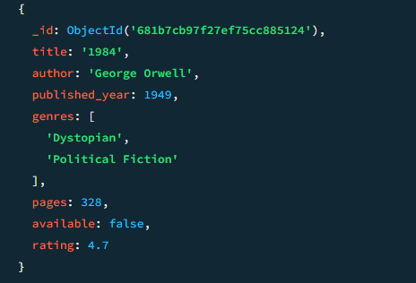
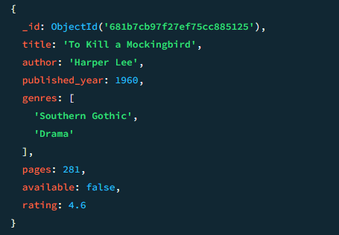

11.Sort books by rating descending:
db.books.find().sort({rating: -1})
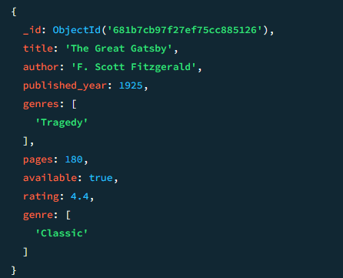
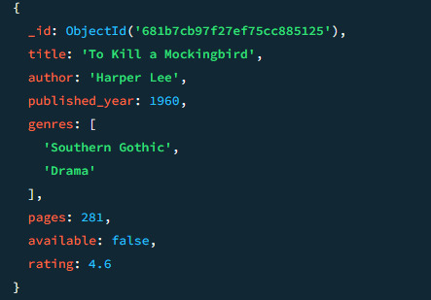
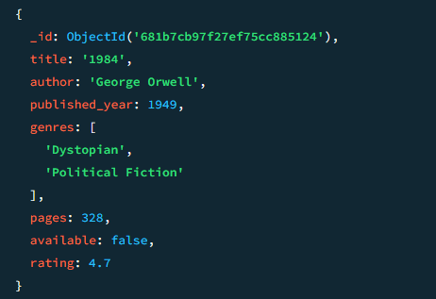
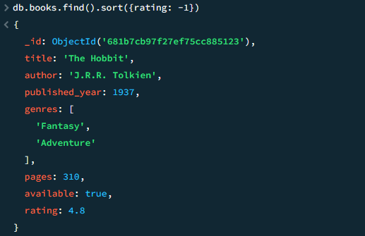
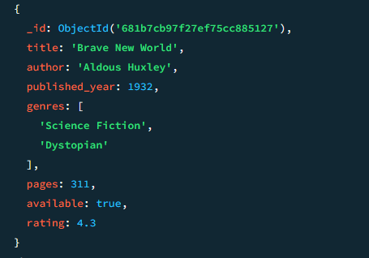

12.Delete all books with a rating lower than 4.5:
db.books.deleteMany({rating: {$lt: 4.5 }})
